A-Level Business Guide

How Business is taught:
- 5 lessons per week that will be, depending on the topic of learning, a combination of the following types of learning:
  - Discussion about the language used to illustrate how markets and businesses work
  - Investigation of business theories, including a critique of those theories
  - Simulations to highlight a business theory or concept
  - Case study analysis to highlight a theory or concept
  - Exam questions to build and assess key writing and maths skills

Working expectations:
- Attend all lessons
- Complete all homework
- Contribute ideas to lessons
- Be prepared to make mistakes and get answers wrong!
- Keep an organised folder with work filed in sections
- Complete all tasks to the best of your ability
- Proof read and check your work before handing in
- Seek guidance and help when required

What 100% effort in this subject looks like:
- Completing all class and homework tasks to a high standard
- Not giving up when you get an answer wrong or have a ‘bad’ lesson
- Being punctual to lessons and submitting homework on time
- Having the resilience and maturity to correct mistakes and discuss issues
- Reading the BBC news every day, especially the business and economy sections and keeping a print out of interesting articles
- Watching online tutorials to check your understanding and practise problem solving
- Completing additional exam paper questions
- Reading business books for pleasure, such as The Invincible Company: How to Constantly Reinvent Your Organization with Inspiration From the World′s Best Business Models

What marking looks like:
- Class notes are not marked
- Knowledge, application and multi choice assessments are self-marked with teacher feedback
- Assessments are teacher marked with GPA feedback and improvements.
- Longer written work is marked by teachers with GPA feedback
- Verbal feedback given in all lessons
What homework looks like:
- Learning key terms or diagrams for a weekly test
- Completing or marking an exam question
- Watching an online tutorial to be able to teach it or discuss it next lesson
- Revision exercises for tests

Specification at a glance:
The subject content for A level Business will be assessed across three examination papers.
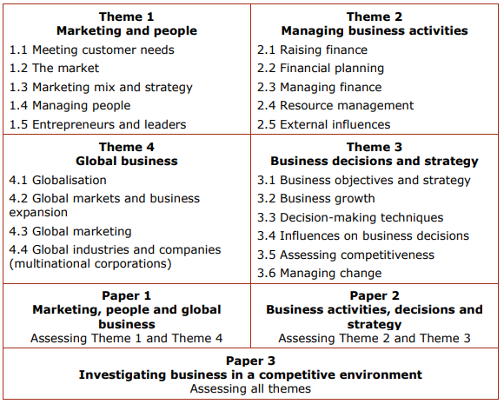

Summer A Level Business Bridging Work
https://app.senecalearning.com/dashboard/class/7r3hacb7tu/assignments/assignment/e53ea60b-8be6-410c-b208-35d4f6458392

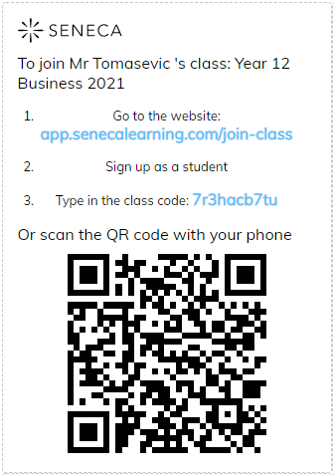

Task: Complete all set tasks on Seneca regarding ‘The Market’, ‘Marketing’ and ‘Leadership’.

Good luck!
Mr Tomasevic

