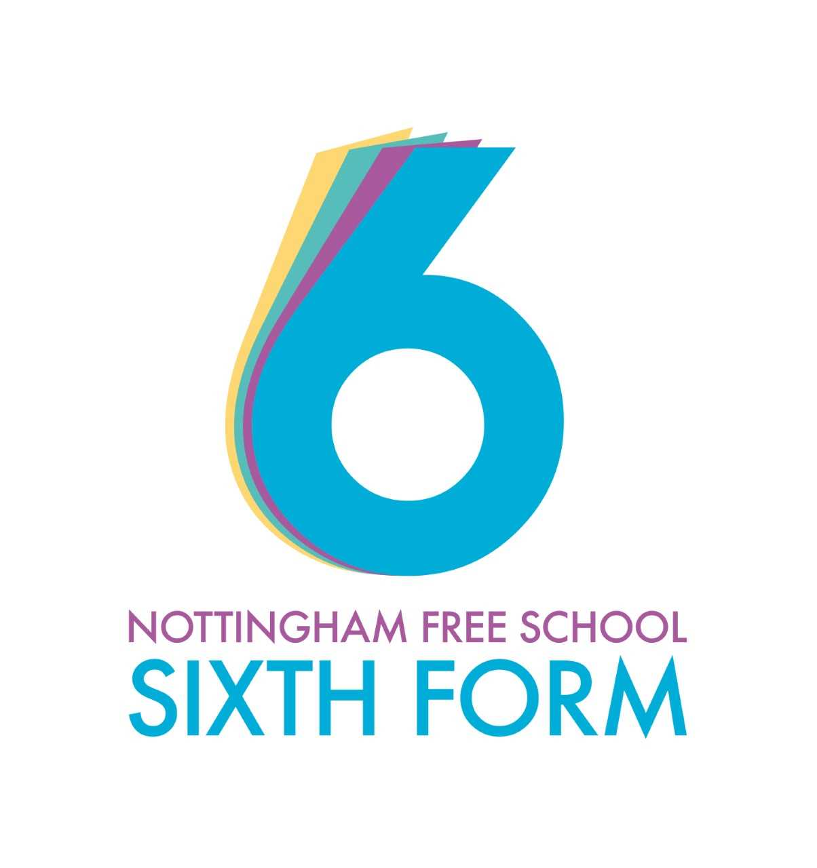 A-Level Fine Art Guide
How Art will be taught:
- Skills workshops and demonstrations
- Group discussions & critiques.
- Staff presentations and explanations.
- Individual mentoring.
- Exploration of artists through contextual analysis.
- Independent research and exploration both in class and in own time.
- Theory tasks are often explained in lessons but completed independently.
- Lesson time is mainly practical using a wide variety of skills and materials.

Working expectations:
- Attend all lessons.
- Complete the allocated independent study time.
- Complete all tasks to the best of your ability.
- Meet deadlines set.
- Ask for help or advice if required.
- Work well independently and with others.
- Be willing to share ideas and opinions.
- Attend Life Drawing classes after school for 5 weeks.
- Taking high quality photographs to support your work.

What 100% effort in this subject looks like:
- Completing theory tasks for deadlines.
- Working on practical tasks in independent study to ensure they are finished to your best standard.
- Listen to the advice you are given and act upon it.
- Learn and develop your skills by practising new techniques that you have been taught in class.
- Finish work for deadlines and act quickly on written feedback.
- Further reading of your topic for your personal study- this could be Art movements or historical ones.
- Visits to galleries.
- Excellent use of presentation once your sketchbook portfolio has been started.
- The use of primary images (your own photography) to explore your project wherever possible.

Folder Policy:
In Art you will have a folder to keep lose work, this should contain:
- All practical work- (even if you think it isn’t good enough-we learn from our mistakes).
- Any written work, either research/contextual analysis of artists.
- All marked work and feedback sheets.
- Any mark sheets from your projects.
- Any photography you have done to explore your ideas.

What marking looks like:
- Just like GCSE, Art A level is marked using 4 Assessment objectives.
- AO1 :Develop ideas through sustained and focused investigations informed by contextual and other sources, demonstrating analytical and critical understanding.
- AO2 :Explore and select appropriate resources, media, materials, techniques and processes, reviewing and refining ideas as work develops.
- AO3 :Record ideas, observations and insights relevant to intentions, reflecting critically on work and progress.
- AO4 : Present a personal and meaningful response that realises intentions and, where appropriate, makes connections between visual and other elements.
- You will receive regular written feedback on your research and contextual analysis.
- You will receive verbal feedback on your practical work every lesson- you may choose to write notes.
- Formalised marking of practical work will be on separate sheets which will include areas for you to write on to help you move forward and progress within Art.

What homework looks like:
- Theory tasks will be set with clear deadlines.
- The expectation is that you continue working on your practical work from class in your independent study time each week. Your teachers will know if you are not spending enough time on it.
- As you move towards your personal study in the middle of Year 12 you will have a time line, this will have clear deadlines set out. It is then your responsibility to use your independent study time along with your class time to ensure these deadlines are met.

Specification at a glance:
Overview
- Learners should be able to explore, research and acquire techniques and develop their skills, knowledge and understanding in a range of Fine Art media.
- Learners should explore relevant images, artefacts and resources relating to Fine Art. Learners may use traditional methods and/or digital techniques to produce Fine Art work.
- Learners in Fine Art are expected to demonstrate specialisation in particular materials, media or processes to allow for an appropriate depth of study. This can be achieved by working toward the extension and development of particular themes, ideas or issues.
- Drawing skills should be understood and developed as appropriate to the ways of recording and communicating intentions, ideas and emotions in the context of Fine Art.

There are 2 main components to Art A Level:
Practical Portfolio & Related Study (60%): This is a practical project covering the 4 assessment objectives based on a theme that you have chosen. Alongside this you must also complete a related study which is an essay (1000-3,500 words) that explores a question linked to the theme you have chosen.
Externally Set Task (40%): The exam board send five titles at the start of February in Year 13, you will then have the time until the exam to complete a practical project based on your chosen theme. The final piece for this will then be completed in a 15 hour exam.

Summer preparation
The purpose of giving you a summer bridging task is:
- To provide a bridge from level 2 to level 3 study, and lead into the early stages of the course.
- To engage you in independent learning which is required at level 3.
- To encourage you to develop your work ethic and commitment to study.
- To measure your suitability for the course and assess your initial levels of achievement.
Task 1: At the start of next year we will be developing portraiture and figurative drawing skills. Familiarise yourself with the facial proportions- see attached document and practice drawing portraits. At first focus on the facial proportions only using simple line drawings. When you are confident that these are totally accurate start developing a range of tone. You can start with pencil but when you are more confident work with paint. Maybe have a go at using some expressive brushstrokes like Lucian Freud. If you really want to challenge yourself try drawing a child!
Task 2: Watch this 5 minute clip:
“The Greats Learning to draw”
Lachlan Goudie
https://www.bbc.co.uk/programmes/p08252dp
Then:
Familiarise yourself with the attached powerpoint called an introduction to life drawing, read through the instructions and have a go at movement lines as a basic starting point. If you have a printer you can print off the slides of various people to have a go yourself.
Then:
Sit yourself with a pen and pad in your house where someone else is in the room. Don’t ask them to pose instead try to record them as quickly as possible- you could simply start with gesture lines as shown in the powerpoint. If they move overlap it with your drawing to create a fluid use of line and movement. This activity will help develop your drawing skills and loosen your use of line. This will help prepare you for life drawing lessons when sometimes you will only get a minute or two to record a pose before it changes. Obviously if someone is willing to pose for you then ask them to change the pose every minute- we’ll look forward to seeing your results! If you want to challenge yourself then try a more detailed figure drawing one with tone once you have mastered the above.
Task 3: Watch at least one (or all three) of the following documentaries about analysing art. Make notes. Then choose a piece of art and have a go at analysing it yourself. Don’t worry if you find this difficult- just have a go!
“Art Mysteries” (Recently shown on BBC) good for analysing and understanding themes in art).
Waldemar Januzczak
https://www.bbc.co.uk/iplayer/episode/m000gx1h/the-art-mysteries-with-waldemar-januszczak-series-1-3-gauguins-vision-after-the-sermon
https://www.bbc.co.uk/iplayer/episode/m000gp0h/the-art-mysteries-with-waldemar-januszczak-series-1-2-seurats-les-poseuses
https://www.bbc.co.uk/iplayer/episode/m000h3dw/the-art-mysteries-with-waldemar-januszczak-series-1-4-cezannes-card-players
Further Tasks :
Please complete the following tasks. They can be done in any order:
- Take a series of photographs ‘Isolation 2020’. Use this title to come up with an idea to create a series of photographs that explore or represent isolation. These could be a series of portraits, you might choose to take photos on your daily exercise or objects around your house-whatever you want to photograph! Once you have taken the photographs choose your best 6 photos. If you have the ability and resources to edit them then edit away.
- Choose at least two from the options below to watch and explore, the more you watch the more you will expand your knowledge of Art and therefore be better equipped for A level.

“The Shock of the New”
Robert Hughes
https://www.youtube.com/watch?v=J3ne7Udaetg

“Age of Image”
Dr John Fox (series 1 episodes 1-4
https://www.bbc.co.uk/iplayer/episode/m000fzm9/age-of-the-image-series-1-1-a-new-reality
https://www.bbc.co.uk/iplayer/episode/m000g6mj/age-of-the-image-series-1-2-power-games
https://www.bbc.co.uk/iplayer/episode/m000gg2h/age-of-the-image-series-1-3-seductive-dreams
https://www.bbc.co.uk/iplayer/episode/m000gnzv/age-of-the-image-series-1-4-fake-views

“The History of Art in three Colour”
Dr John Fox
  - https://www.dailymotion.com/video/x74et8w (white)
  - https://www.youtube.com/watch?v=JJAUTPtppYY (gold)
https://www.youtube.com/watch?v=5OTngEHvq8Q (blue)

“How Art began”
Anthony Gormley
https://www.bbc.co.uk/iplayer/episode/b0c1ngds/antony-gormley-how-art-began

Please bring your work with you to your first lesson.
Link to the Specification: https://www.ocr.org.uk/Images/170210-specification-accredited-a-level-gce-art-and-design-h600-h606.pdf

