Look, say, cover, write, check

Spelling | Look | Say | Cover | Write | Check | Correction

Chunking

List to remember | Written Alphabetically | Grouped | Cover and Write out attempt 1 | Cover and Write out attempt 2

Question and Answer
Ask someone to write you out 5 questions on the section you are learning.
Question | 1st attempt answer | Correction | 2nd attempt answer | Correction
1.

2.

3.

4.

5.

Clock Learning

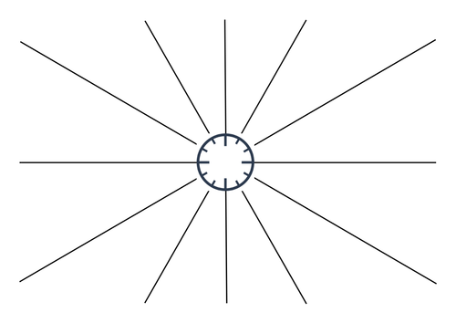
Mind Map

