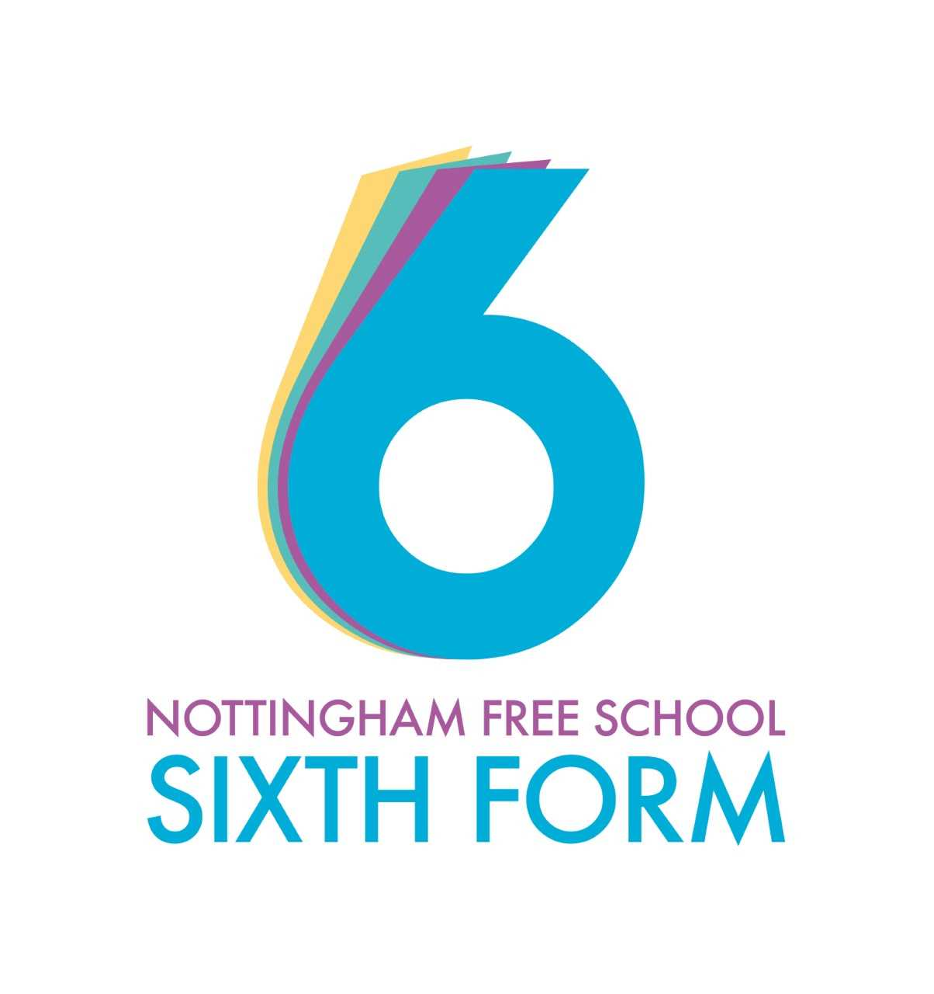 A-Level English Literature Guide
How English Literature will be taught:
- Whole class discussions
- Small group tasks and discussions
- Reading in class
- A significant amount of reading at home
- Note taking and essay writing
- Research in class and independently

Working expectations:
- Attend all lessons
- Complete organised and neat notes
- Complete all tasks to the best of your ability
- Ask for help if required
- Work well independently and with others
- Be willing to share ideas

What 100% effort in this subject looks like:

- Seeking additional essay questions, doing them as practice and handing them in.
- Making your own revision booklets
- Reading about the wider context, such as creating timelines covering the historical periods of the chosen texts
- Reading linked texts from the author or time period
- Watching theatre/film versions of texts
- Listening to podcasts and reading articles about the subject

Folder Policy:
Your folder should have:
- Clear notes on each separate text
- Separate sections for each teacher and text
- Notes on context
- Marked essays to show progress
- Sample essays and other revision materials in the back of the folder

What marking looks like:
- Class notes are not marked
- Research homework will be marked visually but not graded
- Analysis homework will be marked with comments
- All essays/practice exam questions will be marked with comments and a numbered mark

What homework looks like:
- Reading
- Text annotation
- Research
- Exam questions
- Plan a presentation

Specification at a glance:
Paper 1: Love through the ages
Written exam: 3 hours
40% of A-level
Section A: Shakespeare (Othello): one passage-based question with linked essay (25 marks)
Section B: Unseen poetry: compulsory essay question on two unseen poems (25 marks)
Section C: Comparing texts: one essay question linking two texts (Pre-1900 poetry and The Great Gatsby by F Scott Fitzgerald) (25 marks)
Paper 2: Texts in shared contexts
Modern times: literature from 1945 to the present day
Written exam: 2 hours 30 minutes
Open book
40% of A-level
Study of three texts: one prose (The Handmaid’s Tale by Margaret Atwood), one poetry (Feminine Gospels by Carol Ann Duffy), and one drama (A Streetcar Named Desire by Tennessee Williams)
One question on Handmaid’s Tale (25 marks)
One question on an unseen extract (25 marks)
One question on poetry and Streetcar (25 marks)

Non-exam assessment: Independent critical study: texts across time
Comparative critical study of two texts, at least one of which must have been written pre-1900
One extended essay (2500 words) and a bibliography
50 marks
20% of A-level

Summer preparation tasks

The purpose of giving you a summer bridging task is:
- To provide a bridge from level 2 to level 3 study, and lead into the early stages of the course.
- To engage you in independent learning which is required at level 3.
- To encourage you to develop your work ethic and commitment to study.
- To measure your suitability for the course and assess your initial levels of achievement.
Task 1: There are a number of key terms that crop up throughout the two-year course. It is important that you are aware what the meaning is of these terms.
Define the following key terms:
feminism | dystopia | protaganist | allegory | motif | conceit
ambiguity | chronological | catalyst | subvert | diction | analeptic/proleptic narrative

Further Tasks:

Please complete the following tasks. They can be done in any order:

- Complete the power point on the opening of A Streetcar Named Desire
- Complete the power point on hopelessness
- The unit you will be starting with is Literature from 1945 to present. Create a timeline including significant dates since then of:
Literary publications/events eg births/deaths of authors, publication dates of novels/plays/poetry etc
Other entertainment events eg music, film
World events eg wars, political events, births/deaths of significant public figures
Plus any other dates/events you feel are significant eg technological, theories particularly feminism, travel, food etc
This needs to be a detailed timeline and you need to be able to talk about everything you have included so make sure you understand it all. I suggest you use colours and images too.
- Read at least 2 of the texts on the recommended reading list attached. Make notes on each text and be prepared to talk about it in September.

Please bring your work with you to your first lesson.
Potentially useful websites:
https://lithub.com/
http://crossref-it.info/
https://www.gutenberg.org/
http://www.litcharts.com/lit/othello
https://www.sparknotes.com/shakespeare/

Link to the Specification:
https://www.aqa.org.uk/subjects/english/as-and-a-level/english-literature-a-7711-7712/specification-at-a-glance

