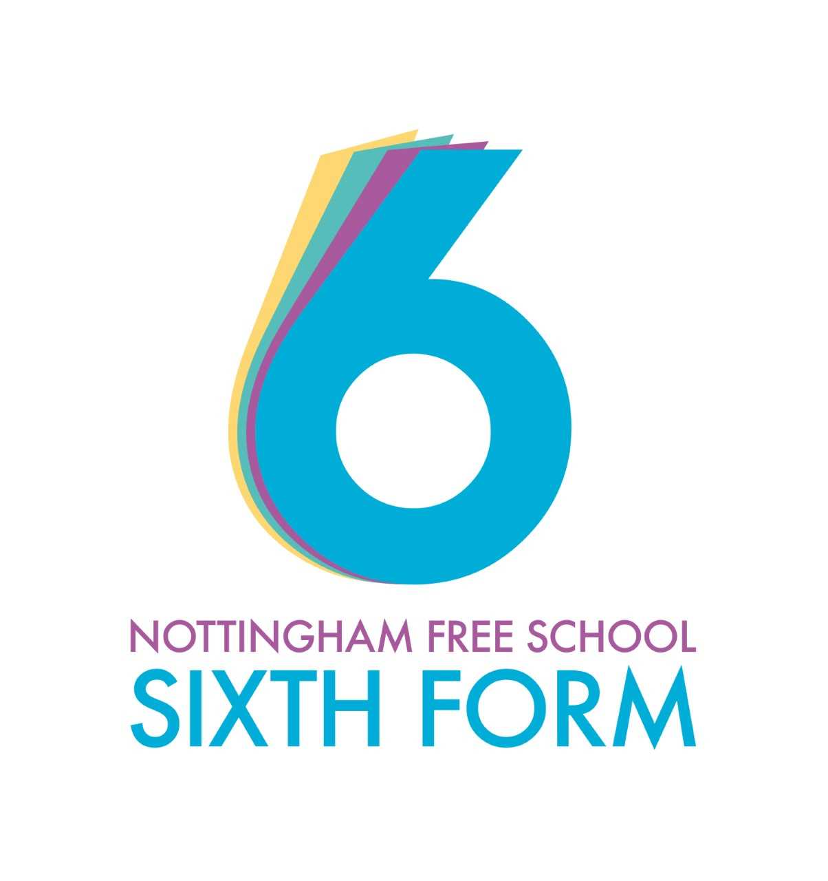
A-Level Religious Studies A level Guide
How Religious Studies will be taught:
- Lots of class discussions
- Small group tasks
- Reading in class
- A significant amount of reading/research at home
- Note taking and essay writing
- Presenting in class
Working expectations:
- Attend all lessons
- Complete organised and neat notes
- Complete all tasks to the best of your ability
- Ask for help if required
- Work well independently and with others
- Be willing to share ideas
- Meet deadlines
What 100% effort in this subject looks like:
- Seeking additional essay questions, doing them as practice and handing them in.
- Making your own revision resources
- Reading about the wider context, such as keeping up to date with contemporary thinking
- Wider reading
- Watching documentaries/films relevant to the course
- Listening to podcasts and reading articles about the subject

Folder Policy:
Your folder should have:
- Separate folders for each part of the course (Islam, Philosophy, Ethics).
- Syllabus content front sheet for each topic.
- Clear notes filed with relevant PPT
- Sample essays and other revision materials in the back of the folder
- Marked essays to show progress kept neatly in separate folder in school with progress sheet
What marking looks like:
- Class notes are not marked
- Research homework will be marked visually but not graded
- All essays/practice exam questions will be marked with comments and a numbered mark
What homework looks like:
- Reading
- Research
- Exam questions
- Plan a presentation
- Revision activity
- Preparing for a test

Specification at a glance:
Subject: Religious Studies Philosophy and Ethics
Exam Board: Eduqas
What will I learn?
Component 1: A Study of Religion: Islam
Written examination: 2 hours 33⅓% of qualification
There will be four themes within each option:
- religious figures and sacred texts;
- religious concepts and religious life;
- significant social and historical developments in religious thought; (E.g. gender)
- religious practices and religious identity.

Component 2: Philosophy of Religion
Written examination: 2 hours 33⅓% of qualification
There will be four themes within this component:
- arguments for the existence of God; (e.g Design Argument)
- challenges to religious belief; (e.g. Evil and Suffering)
- religious experience; (E.g. Miracles)
- religious language. (E.g. Language Games)

Component 3: Religion and Ethics
Written examination: 2 hours 33⅓% of qualification
There will be four themes within this component:
- ethical thought;
- deontological ethics; (E.g. Natural Law)
- teleological ethics; (E.g. Utilitarian Ethics)
- determinism and free will.

How am I assessed?
3 x 2 hour exams on each component.
What do I need to study this course?
College Entry Requirements are a Grade 5 in GCSE Religious Studies or English.
Where can it lead?
Many students go on to study Philosophy, Theology, Law, Criminology, Medicine, Sciences, Philosophy, Politics and Economics, English, History and Social sciences. Career paths could be Doctor/other medical professional, Lawyer, Journalist, Teacher, Police Force, Politics and Business Management.

Bridging Tasks
The purpose of giving you a summer bridging task is:
- To provide a bridge from level 2 to level 3 study, and lead into the early stages of the course.
- To engage you in independent learning which is required at level 3.
- To encourage you to develop your work ethic and commitment to study.
- To measure your suitability for the course and assess your initial levels of achievement.
Task 1: There are a number of key terms that crop up in the first unit. It is important that you are aware what the meaning is of these terms.
Define the following key terms:

Philosophy and Ethics

Deontological | Absolute | Empirical | Non-Contingent | A posteriori | Inductive
Teleological | Relative | Teleological | Infinite Regress | A priori | Deductive

Islam
Jahiliyya | Shaykh | Bedouin | Muruwa | Monotheism | Zorastrianism

Further Tasks:
Please complete the following tasks. They can be done in any order:
- Ethics Task: Watch this. https://www.youtube.com/watch?v=IMPl25oraVc. This is the first episode of Stephen Fry’s series ‘Out There’, where he explores attitudes to homosexuality in different parts of the world. Questions to write about – try to support your answers with reasoning:
- Do you think there is a ‘right’ attitude and a ‘wrong’ attitude towards homosexuality? What is it that makes these attitudes right or wrong?
- Some people might argue that different cultures have different ideas about morality, and that these different cultural beliefs should be respected even if we don’t agree with them. Do you think we should always respect the beliefs and attitudes of cultures different from our own, or should we try to persuade them to adopt our own beliefs instead?
- What do you think are the aims of this television series? Do you think they are good aims? Do you think this first episode is successful in achieving its aims?
- What religious reasons do people sometimes give for opposing homosexual relationships? How would you support or oppose these views?
- Listen to Panpsycasts on the Teleological Argument
https://thepanpsycast.com/panpsycast2/2016/12/11/episode-8-the-teleological-argument-part-i
https://thepanpsycast.com/panpsycast2/2016/12/11/episode-8-the-teleological-argument-part-ii
- Use the peped website to read about your first Philosophy topic: Teleological Arguments
https://peped.org/philosophicalinvestigations/philosophy/as/teleological-argument/
- Read current articles from The Philosophers Magazine.
https://www.philosophersmag.com/
- Play 2 of the games form The Philosophers Magazine.
https://www.philosophersmag.com/games
- Try the ‘brainsqueezers’. These are good if you don’t have too much time, or if you’re finding it difficult to settle to anything more concentrated.
https://www.thephilosophyman.com/brainsqueezers
- TED talks – these are usually wonderful, with plenty to stimulate your questioning and reasoning skills. Some favourites: Elizabeth Loftus – how reliable is your memory? Dan Gilbert – why we make bad decisions, Richard Dawkins – militant atheism, Chimamanda Ngozi Adichie – We should all be feminists, Damon Horowitz – Philosophy in prison. Write notes as you listen and practise the skill of jotting down key points at speed. Ask yourself questions when you get to the end: what were the speaker’s key messages? Do you agree with the speaker? What might someone who disagreed say, and what might their reasons be?
- Key Philosophers Research skills: There are all kinds of resources on line and in books to help you, if you want to start to learn a little more about some of the philosophers you will meet in you're a level course. Use Wikipedia as a starting point and follow some of the links in the articles. Practice using a range of sources to find out about a single person. When you have gathered together range of information, try and synthesise it into a single piece of writing of your own. You could do some research about any of the following: Plato , Aristotle, Aquinas, Bentham, Mill, Hume and Kant
- Watch Something Educational. All kinds of films and series have philosophical and religious ideas in them, so follow your own interests! You could try these, or choose something else, but try and use them as a stimulus for thinking and writing, rather than just sitting in front of them: Try Louis Theroux documentary on Polyamorous relationships: Love without limits and any on the Westborough Baptist Church, The Imitation Game, The Good Place, The Matrix, Unorthodox, Twelve Angry Men, The Boy Who Harnessed the Wind, Greenbook, Z for Zachariah (also a book).
- Brush up on your current knowledge:
BBC bitesize sections on Islam: https://www.bbc.co.uk/bitesize/examspecs/zjgx47h
Seneca particularly the sections on Islam and themes.

Please bring your work with you to your first lesson.
Potentially useful websites:
Panpsycasts - https://thepanpsycast.com/
This website gives lots of interesting, contemporary podcasts on the topics we cover. Browse episodes by category.
The Philosophy Man - https://www.thephilosophyman.com/
This website gives you lots of different ideas to think about.
Philosophers Magazine – https://peped.org/philosophicalinvestigations/
Lots to think about!
Peped – https://peped.org/philosophicalinvestigations/
This website has a lot of good resources that you might use once you start you're a level course; you could dip in and start exploring some of the ideas you will meet next year.
Link to the Specification:
https://www.eduqas.co.uk/qualifications/religious-studies/as-a-level/
Further Reading
Sophie's World by Jostein Gaarder, The Philosophy Book: Big Ideas Simply Explained, The Blind Watchmaker, and/or The God Delusion – Richard Dawkins, The Puzzle of… - Peter Vardy – this series of non-fiction books is about issues in religion and philosophy, very readable and you don’t have to be an expert to enjoy them. You can dip in and out of different chapters rather than having to start at the beginning and work through to the end.

